**Course:** Digital Image Processing (CSC331) **Class:** BSSE (6th A, 6th B)



**Submitted By:** laiba binte tahir

**Reg No#** FA21-BSE-019

**Submitted To:** Dr. Mubashir Ahmad

# Question:

**Q no 1.** Please write down the HSI color model in detail and convert the following RGB colors into HSI colors. CLO-4 (PLO-2 C3)

|  |  |  |
| --- | --- | --- |
| **R** | **G** | **B** |
| 100 | 200 | 180 |
| 25 | 45 | 254 |

# HIS model Intoduction

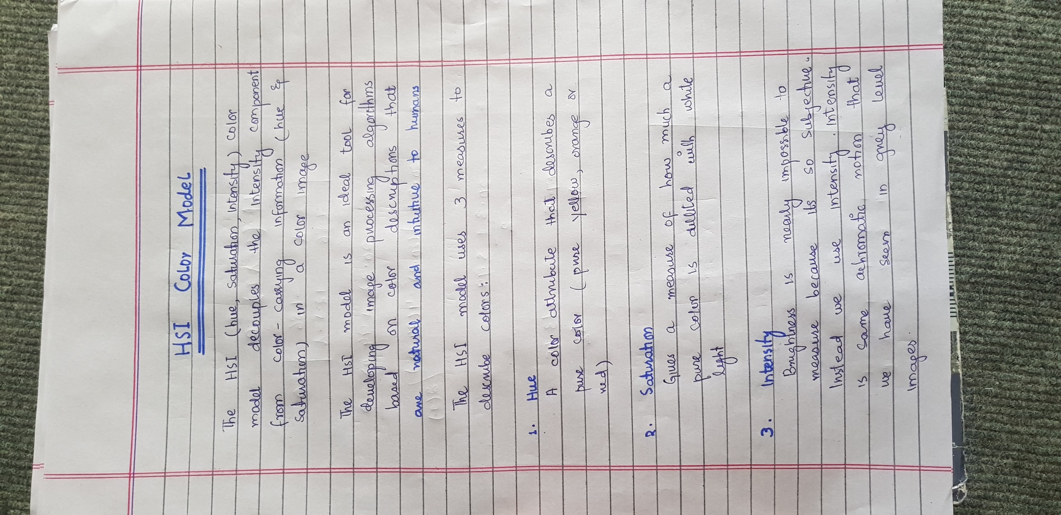

# Relation b/w RGB and HSI

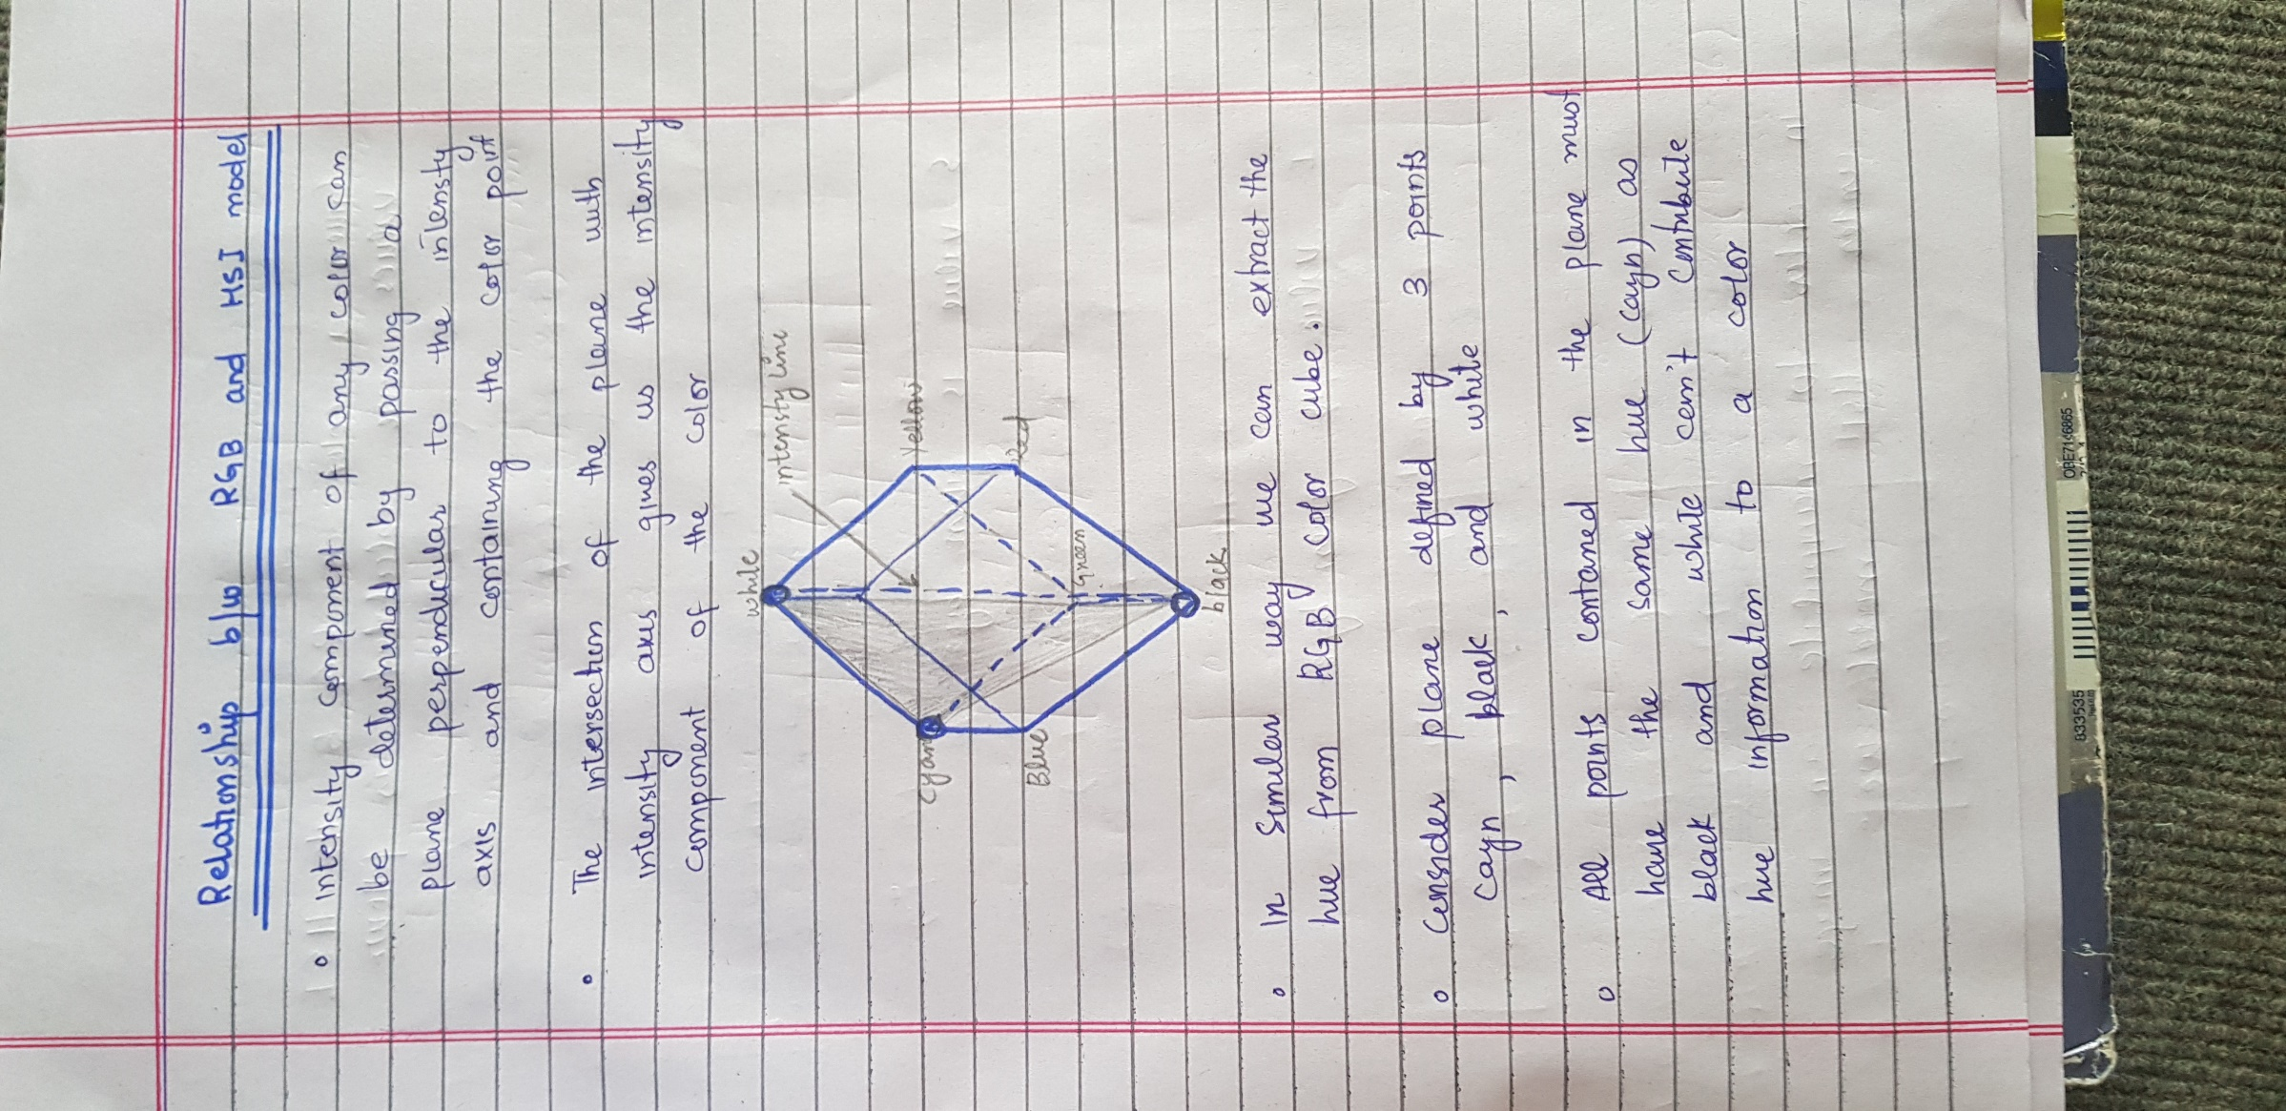

# Conversion From RGB to HIS

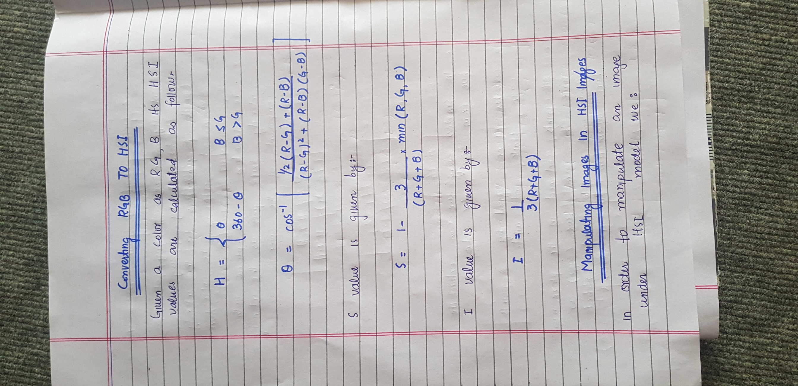

# Manipulation of image in HSI

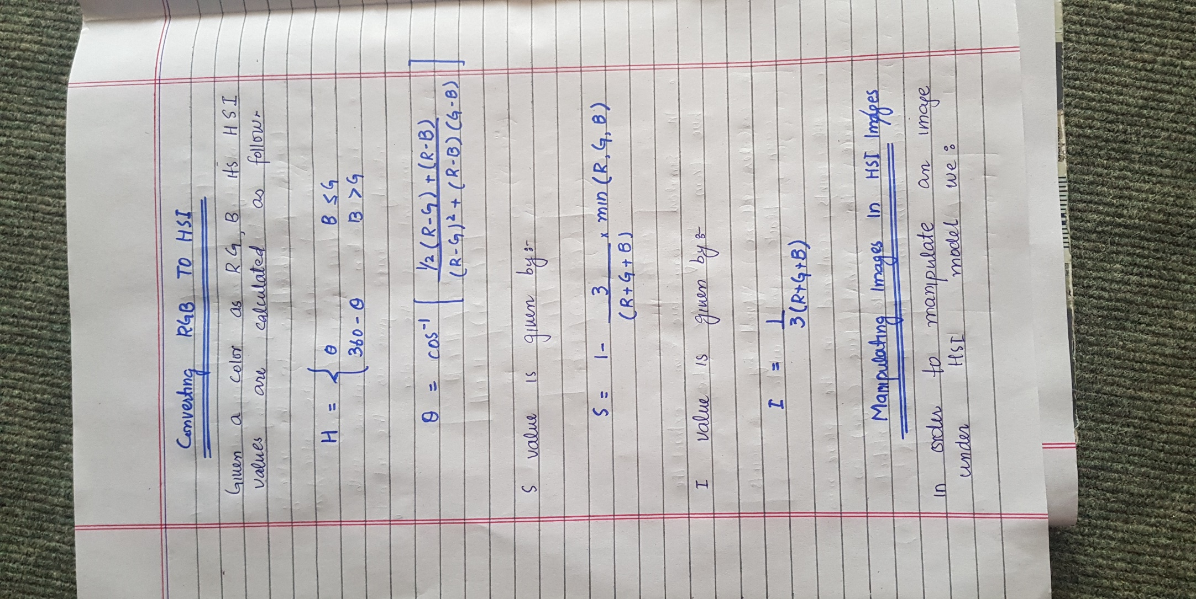

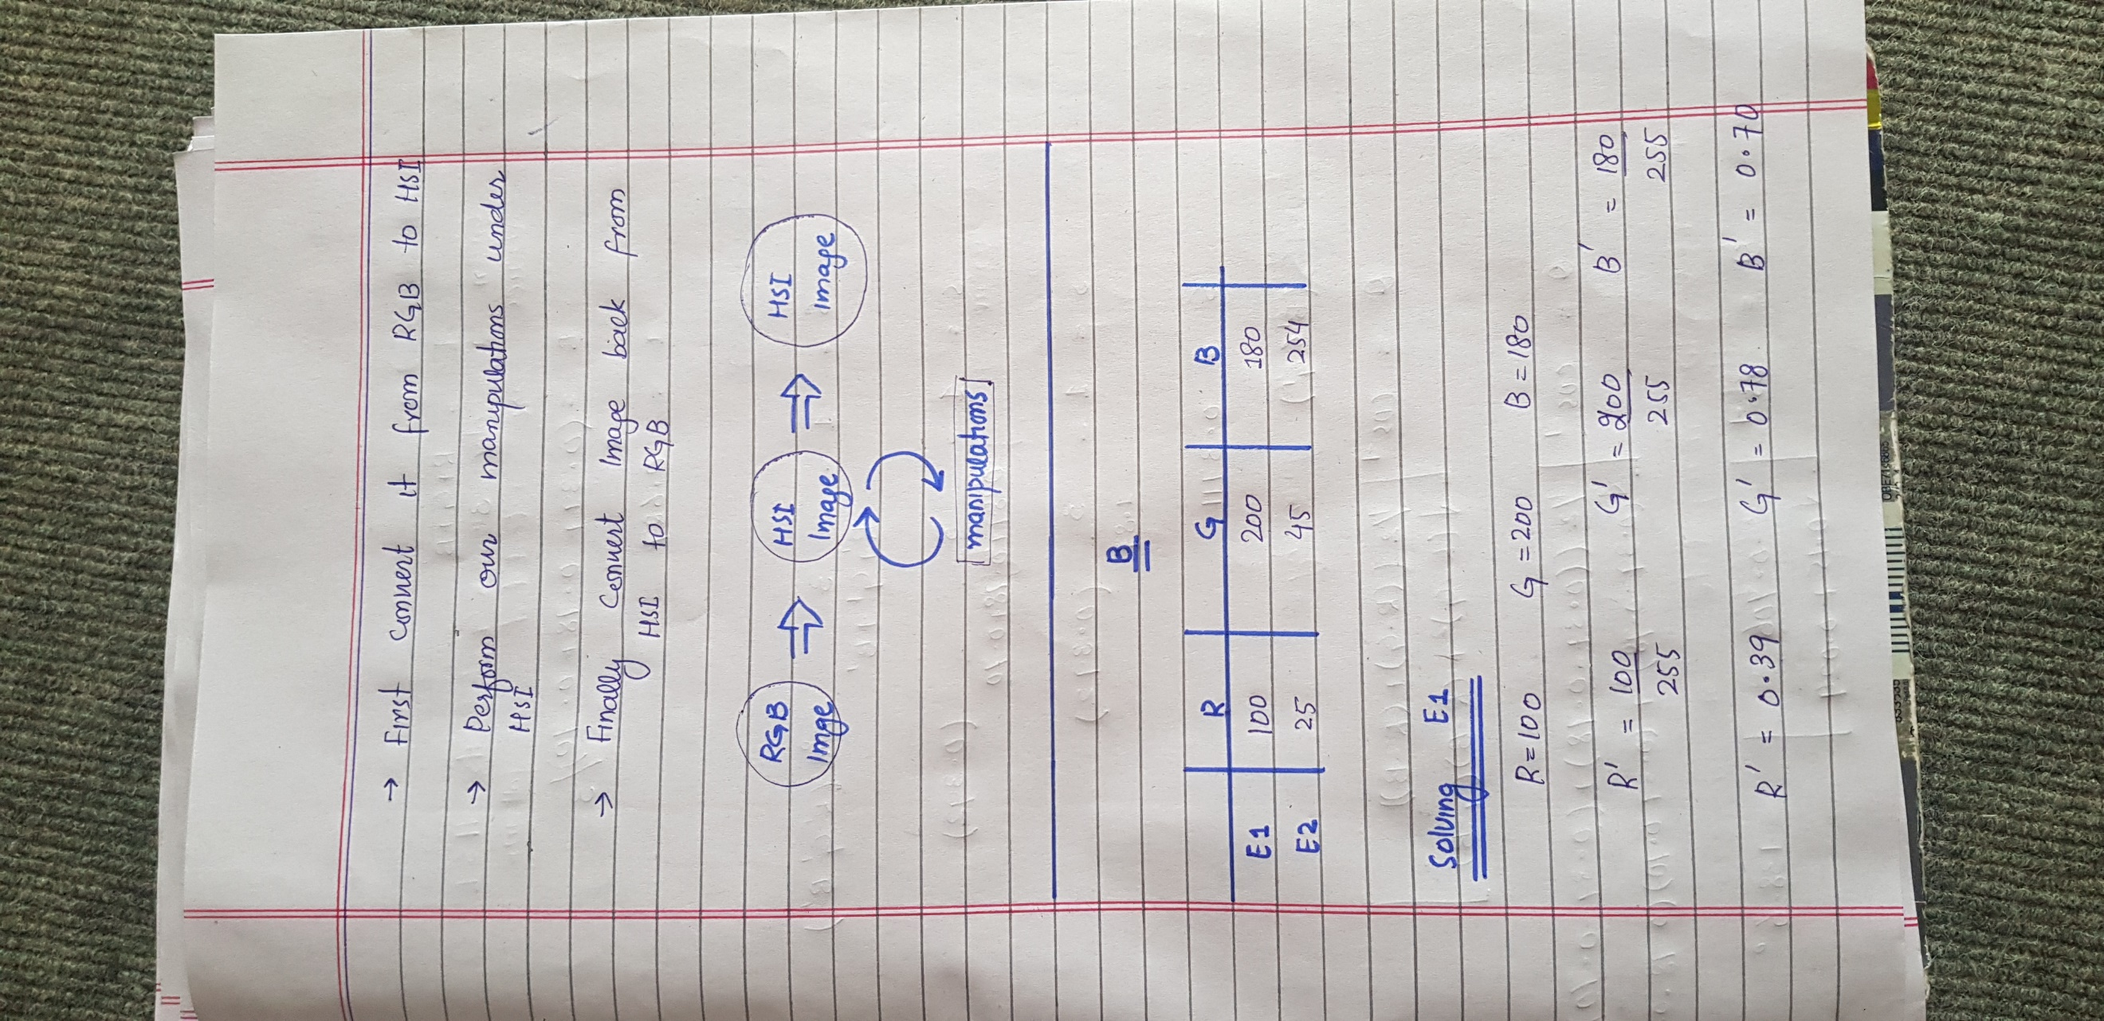

# convert the following RGB colors into HSI colors. CLO-4 (PLO-2 C3)

|  |  |  |
| --- | --- | --- |
| **R** | **G** | **B** |
| 100 | 200 | 180 |
| 25 | 45 | 254 |

